CodeChef Recruitment Task Solutions

Name: Madhav Choudhary
Reg No: 25BCE0431

Problem 1: Lanvishus Language Notes

Approach: In the given problem we have to convert the singular form words given to the program ending in “us” to the plural form ending in “oi”. There is a static, fixed conversion rule so we can use easy string manipulation. Instead of creating a totally different new string, I changed the existing string by accessing the last two places (length-2 and length-1) to achieve O(1) efficiency per test case.

Code:
#include <cmath>
#include <cstdio>
#include <vector>
#include <iostream>
#include <algorithm>
#include <string>

int main() {
int t {};
std::string word;
std::cin >> t ;
while(t--) {
std::cin >> word;
int len = word.length();
word[len-1] = 'i';
word[len-2] = 'o';
std::cout << word << '\n';
}

return 0;
}

Test Cases:
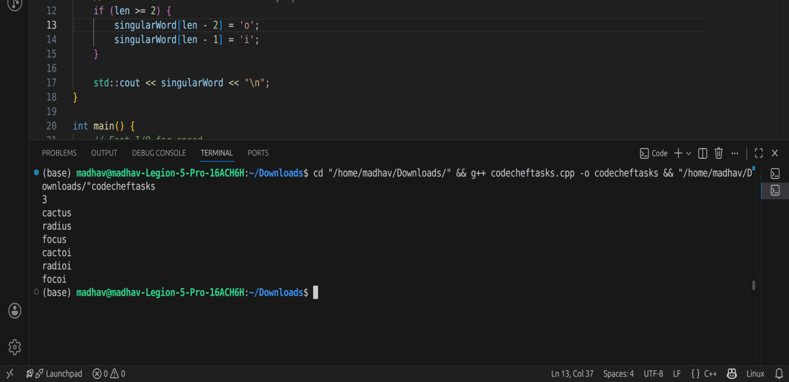
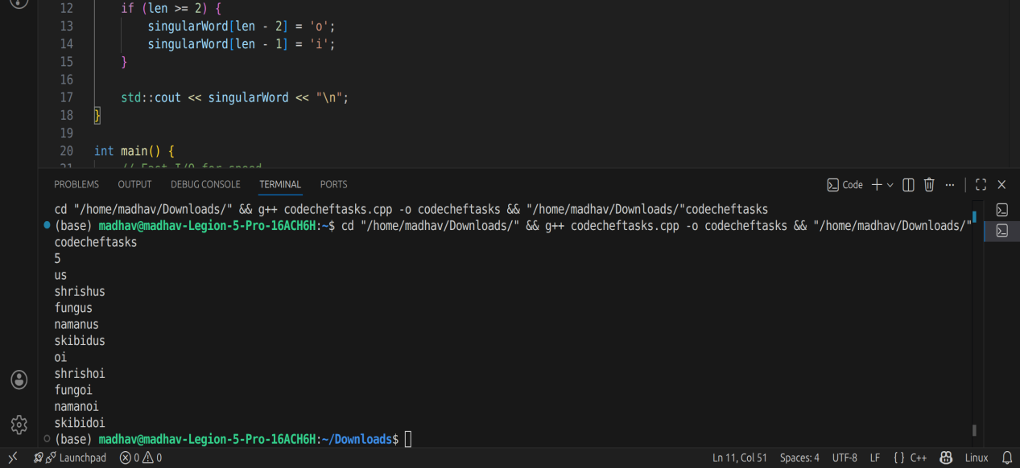

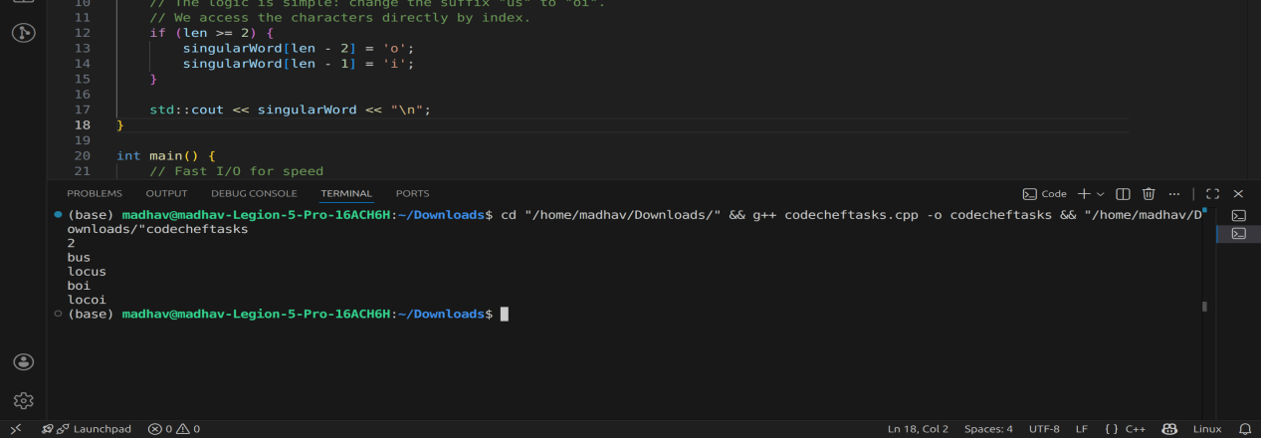

Problem 2 : Spiciness (Stew & Chillies)
Approach: The problem asks if we can sequence the chilles so that the final stew spiciness of the stew returns to 1.The formula for the same is
Final Spiciness = Last Chilly/First Chilly. For the result to be 1, the first and last chllies must have the same value.Therefore, the problem simplifies to analzying if there are any identical terms in the input array. I sorted then sorted array (O(NlogN)) and checked adjacent chillies to find duplicates efficiently.

Code:

#include <cmath>
#include <cstdio>
#include <vector>
#include <iostream>
#include <algorithm>

int main() {
int t {};
std::cin >> t;
while(t--) {
int n {};
std::cin >> n;
std::vector<int> a(n);

for (int i = 0; i < n; i++) {
std::cin >> a[i];
}

std::sort(a.begin(), a.end());

bool found = false;
for(int i =0; i < n-1;i++){
if(a[i] == a[i+1]) {
found = true;
break;
}
}
if(found) {
std::cout << "YES\n";
}
else {
std::cout << "NO\n";
}

}
return 0;

}

Test Cases:

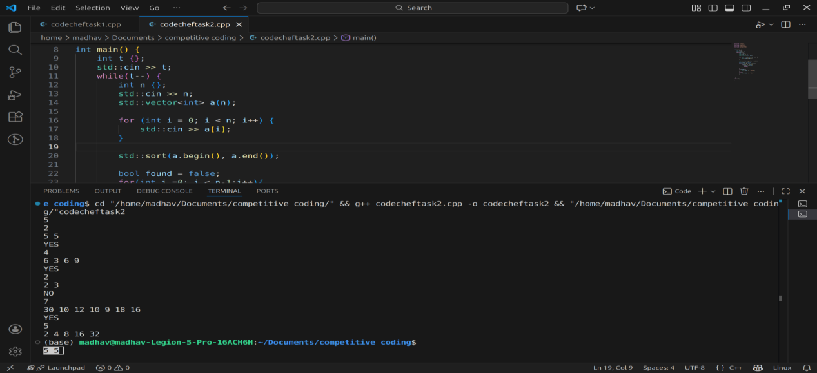

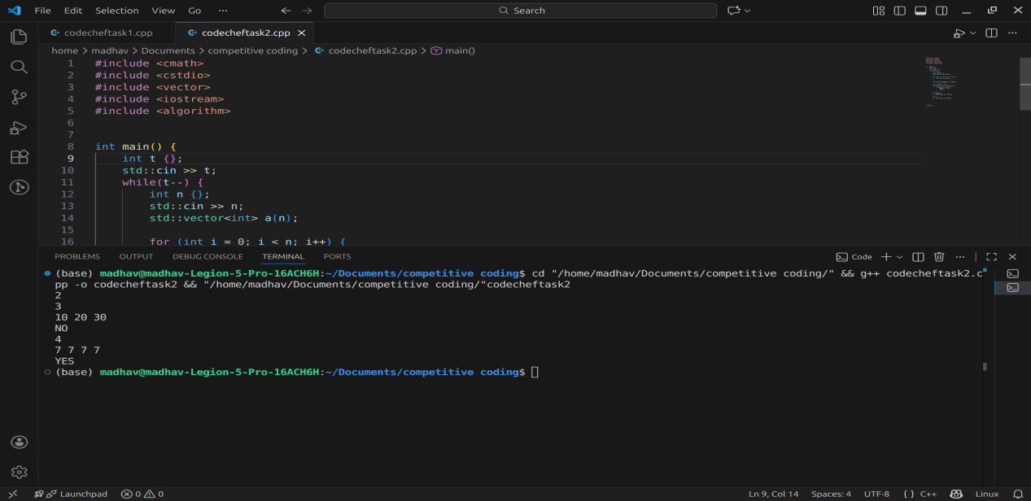

Problem 3 : A Fruitful Stroll

Approach: Our approach for this problem is to find the longest subarray which has 2 different numbers that range up to 10^7, using a nested loop is too slow. Thats’s why i have used a sliding window approach (O(N)).I created variables to track the two active fruit types in the current window(recent and older). When a 3rd type is encountered, I have to shrink the window to recent_run_start(the start of the last continuous run of current fruit), this ensures the window always remain valid while keeping the suffix of the most recent type.

code:
#include <iostream>
#include <vector>

void solve_case() {
int n;
std::cin >> n;

std::vector<int> arr;
arr.reserve(n);

for (int i = 0; i < n; ++i) {
int x;
std::cin >> x;
arr.push_back(x);
}

// Edge-case bailout AFTER reading.
if (n <= 2) {
std::cout << n << "\n";
return;
}

// sliding window stuff
int win_start = 0;

// fruit "types" I am tracking
int recent = -1; // most recent fruit type
int older = -1; // the other one in the window
int recent_run_start = 0; // where the run of "recent" started

int best = 0;

// I might remove this later
int tmp_len = 0;

for (int i = 0; i < n; ++i) {
int f = arr[i];

if (f == recent) {
// nothing special, same fruit as before
}
else if (f == older) {
// swap types: "recent" should always be recent
older = recent;
recent = f;
recent_run_start = i;
}
else {
// new fruit type detected
if (older != -1) {
// shift window to keep only last two types
win_start = recent_run_start;
}

// redo the type tracking
older = recent;
recent = f;
recent_run_start = i;
}

// calculate window length; doing it manually instead of std::max
tmp_len = i - win_start + 1;
if (tmp_len > best) {
best = tmp_len;
}

/*
// Random old idea I tried:
// if (i > 0 && arr[i] == arr[i-1]) { ... }
// but decided it was pointless. Keeping as a note.
*/
}

std::cout << best << "\n";
}

int main() {
std::ios_base::sync_with_stdio(false);
std::cin.tie(NULL); // no sync with stdout

int t;
std::cin >> t;

// loop through testcases
while (t--) {
solve_case();
}

return 0;
}

Test cases:
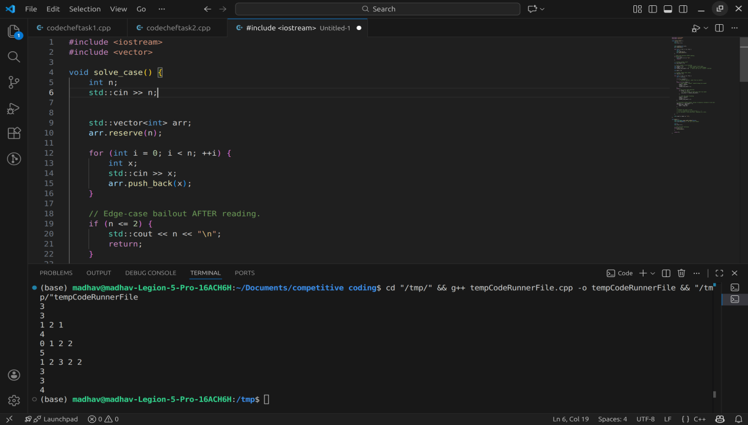

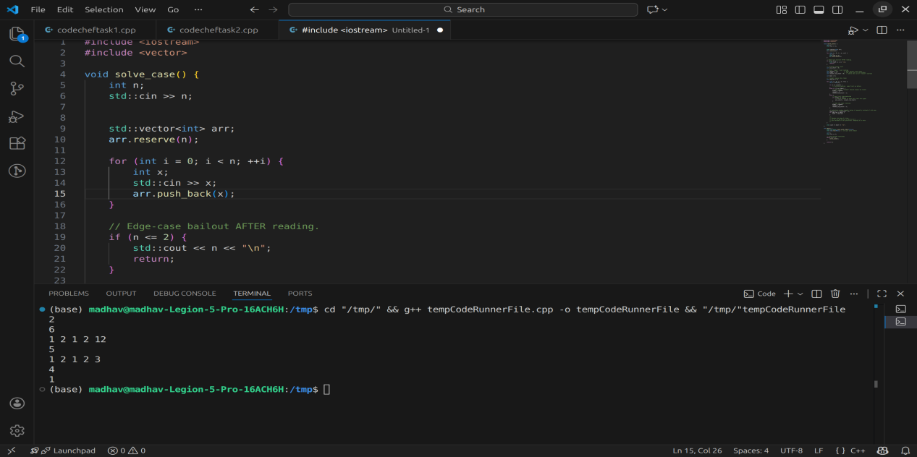
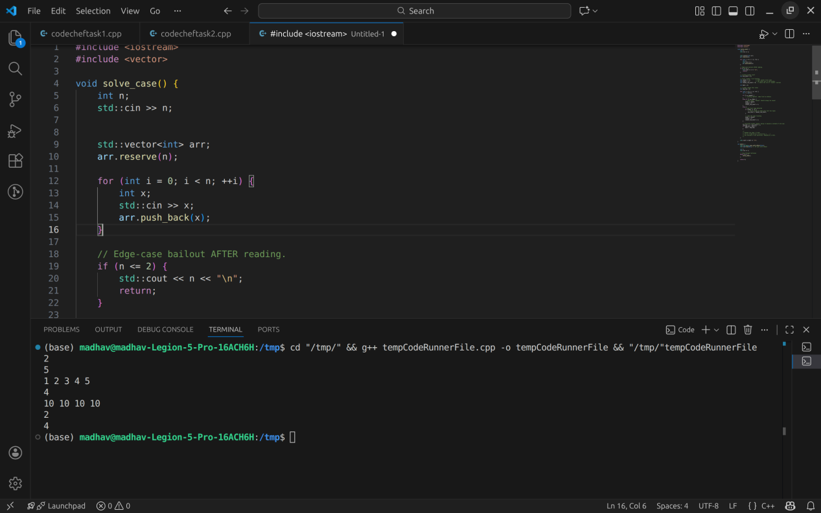

Problem 4 : Hide n Seek

Approach: The problem at its core is asking if king is located on a cycle or a Tree Branch.

- If the king is on a cycle, he can keep running forever so the ouptu will be NO
- If the king is on a branch or (a path ending in a dead end), so the chef can corner him so the output will be YES

For solving this, i used a ‘peeling’ algorithm which is similiar to topological sort. I the iteratively removed the ‘leaf nodes’ which are the nodes with 1 or few connections, to strip away the tree branches of the graph.

- First I stored the graph in graph variable and tracked connection counts using deg variable
- Then, I initialized the queue with all the leaf nodes(deg[i] <= i).
- after which I processed the queue,Then marked the nodes as ‘gone’.When a node is removed I decrease the degree of its neighbours
- Verdict: Then I use boolean flag kingPeeled. So, if the king’s node was processed and removed, it means he was on a branch and will get caught(YES). Then if the queue empties and the King was never peeled, then he is safely inside a the cycle(NO).

Code:
#include <iostream>
#include <vector>
#include <queue>

void runCase() {
int n, m;
if (!(std::cin >> n >> m)) return;

// Graph storage
std::vector<std::vector<int>> graph(n + 1);
std::vector<int> deg(n + 1, 0);

// Build edges
for (int i = 0; i < m; ++i) {
int a, b;
std::cin >> a >> b;
graph[a].push_back(b);
graph[b].push_back(a);
deg[a]++;
deg[b]++;
}

int king;
std::cin >> king;

// Collect leaves
std::queue<int> q;
for (int i = 1; i <= n; ++i) {
if (deg[i] <= 1) {
q.push(i);
}
}

std::vector<bool> gone(n + 1, false);

// Assume king survives unless peeled
bool kingPeeled = false;

while (!q.empty()) {
int u = q.front();
q.pop();

if (gone[u]) {
//small defensive check
continue;
}

gone[u] = true;

if (u == king) {
kingPeeled = true;

}

// Update neighbors
for (int v : graph[u]) {
if (!gone[v]) {
deg[v]--;
if (deg[v] == 1) {
q.push(v);
}
}
}
}

// Output result
if (kingPeeled) {
std::cout << "YES\n";
} else {
std::cout << "NO\n";
}

}

int main() {
std::ios_base::sync_with_stdio(false);
std::cin.tie(NULL);

int t;
if (std::cin >> t) {
while (t--) {
runCase();
}
}
return 0;

}

Test cases:

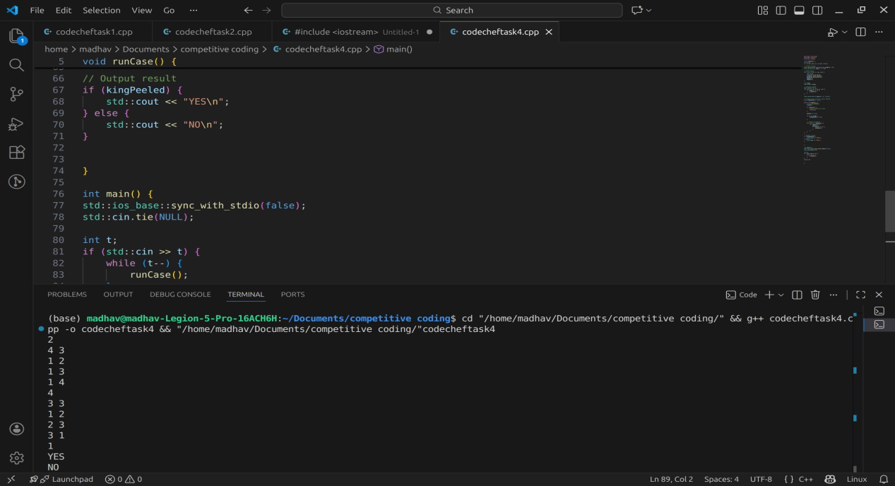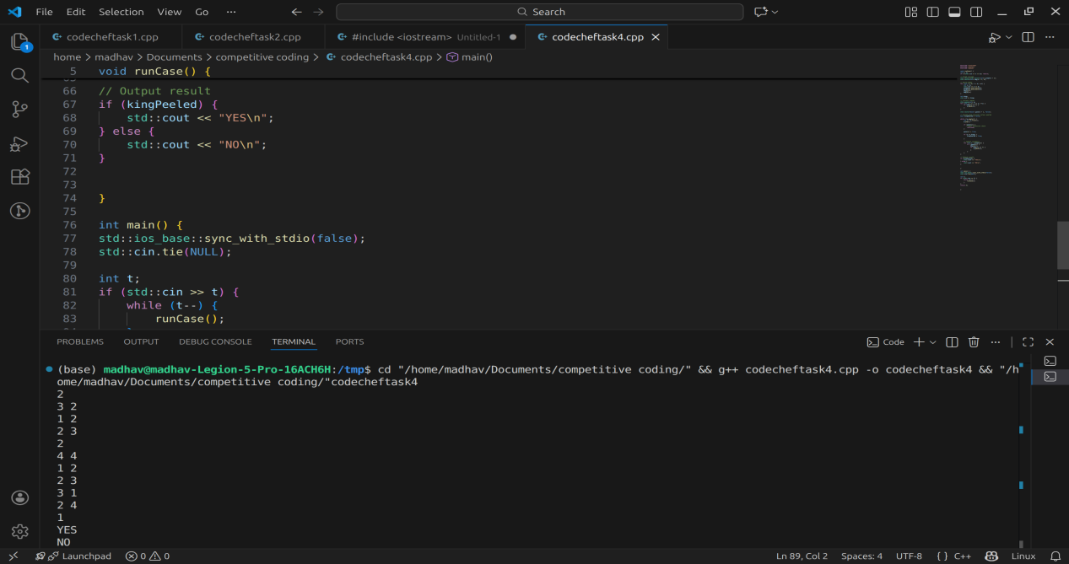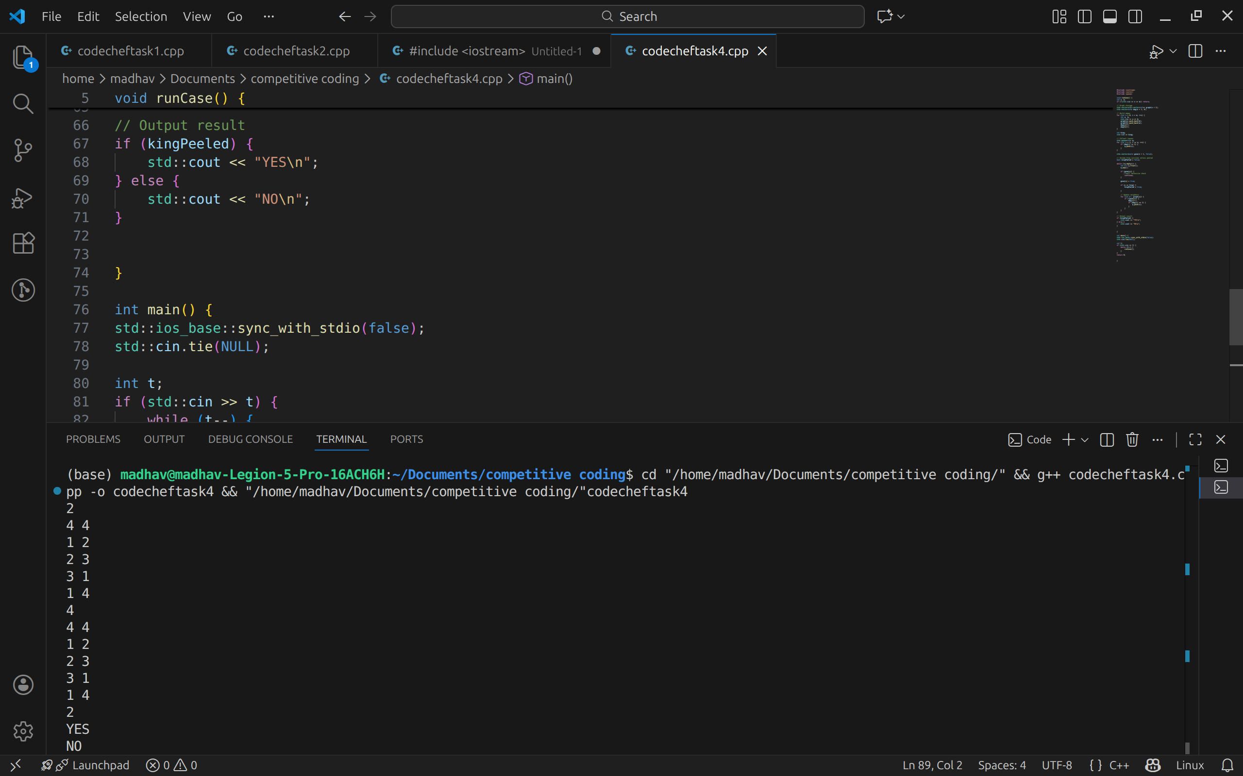
Problem 5 : Mushroom

Approach
We need to make equal the volumes of a Cap (hemisphere) and Stem (cylinder) using binary cuts. I breaked down the volume formulas into two large integers, A and B, by cross-multiplying to remove denominators and constants like π. Since the volumes can be very large numbers, I used __int128 (typedef as int128) to prevent overflow.
Simplification: I reduced the ratio A:B by dividing both by their greatest common divisor (gcd128).
Bitwise Logic: The problem reduces to finding a target power of 2, denoted as K, that can cover the larger of the two numbers (next_pow2_exp).
Calculating Cuts: The number of cuts required is determined by the difference between this target power K and the existing factors of 2 (trailing zeros) in the numbers. I implemented a helper count_tz to count these trailing zeros efficiently.

Code:
#include <iostream>
#include <algorithm>
#include <cmath>

// Keeping __int128 for the huge intermediate values
typedef __int128 int128;

// I like having my own small input reader, even though std::cin >> x is fine.
static long long grab_ll() {
long long v;
std::cin >> v;
return v;
}

// gcd for int128
int128 gcd128(int128 a, int128 b) {
while (b != 0) {
a %= b;
std::swap(a, b);
}
return a;
}

// Count trailing zeros in a binary int128 (factors of 2).
// Very tiny loop, basically O(log n) but n is big; still trivial.
long long count_tz(int128 x) {
if (x == 0) return 0;
long long c = 0;
while ((x & 1) == 0) {
x >>= 1;
++c;
}
return c;
}

// Find smallest k where 2^k >= n.
// Using shifts rather than logs to avoid floating precision issues.
long long next_pow2_exp(int128 n) {
if (n == 0) return 0;

long long k = 0;
int128 t = n;
// basically computing floor(log2(n))
t >>= 1;
while (t > 0) {
t >>= 1;
++k;
}

// verify exponent really fits
if ( ((int128)1 << k) < n ) {
++k;
}
return k;
}

// main logic for each testcase
void solve() {

long long cr_n = grab_ll();
long long cr_d = grab_ll();
long long sr_n = grab_ll();
long long sr_d = grab_ll();
long long sh_n = grab_ll();
long long sh_d = grab_ll();

// Compute the cross-multiplied volumes.
// A = 2 * cr_n^3 * sr_d^2 * sh_d
// B = 3 * cr_d^3 * sr_n^2 * sh_n
int128 A = (int128)2 * cr_n * cr_n * cr_n * sr_d * sr_d * sh_d;
int128 B = (int128)3 * cr_d * cr_d * cr_d * sr_n * sr_n * sh_n;

if (A == 0 || B == 0) {
// trivial case: one side has no volume
std::cout << "0\n";
return;
}

// reduce ratio A:B using gcd
int128 g = gcd128(A, B);
A /= g;
B /= g;

if (A == B) {
// already matched
std::cout << "0\n";
return;
}

// find max exponent needed
int128 bigger = (A > B ? A : B);
long long K = next_pow2_exp(bigger);

// figure out cuts
long long cuts_cap = K - count_tz(B);
long long cuts_stem = K - count_tz(A);

long long answer = cuts_cap + cuts_stem;

std::cout << answer << "\n";

// leftover optional debug block:
// std::cerr << "A=" << (long long)A << " B=" << (long long)B << " K=" << K << "\n";
}

int main() {
std::ios_base::sync_with_stdio(false);
std::cin.tie(NULL);

int t;
std::cin >> t;
while (t--) {
solve();
}
return 0;
}

Test Cases:
